

ALZHEIMER’S DETECTION USING TRANSFER LEARNING

GROUP MEMBERS

Sristi Mitra - 2K19/CO/389 Zishnendu Sarkar – 2K19/CO/450 Ankon Bhowmick – 2K19/MC/019

Submitted to: Prof. Anil Singh Parihar

Semester-VI 2022

CO-324 MTE PROJECT REPORT

CONTENTS

Abstract 2

Introduction 2

Alzheimer’s disease 2

Transfer Learning 3

Methodology 4

Concept used: Transfer Learning 4

Materials 6

Architecture 6

Work Flow 7

Implementation 8

Results 17

Future Scope 18

Conclusion 18

Related Work 3

References 18

ABSTRACT

The vast majority of Alzheimer's disease diagnostic studies (AD) are predicated on the assumption that the training and testing data come from the same distribution. This identical-distribution assumption, however, may not hold true in the diagnosis of AD and moderate cognitive impairment (MCI). We use the transfer learning approach in the diagnosis of Alzheimer's disease to tackle this difficulty. Recently we can see a huge advancement of deep learning in computer vision but the common limitations with such algorithms include the reliance on a large number of training images and the requirement for thorough deep network architecture optimization. In this paper, we have used the transfer learning method with our custom-made dataset where we classified AD, MCI, and normal controls (NC) data from Alzheimer’s Disease Neuroimaging Initiative (ADNI) database and further labelled and managed ourselves. We demonstrate that with a training size of 10 to 20 times less than other existing approaches using our custom dataset. Our study emphasizes the applicability and transferability of spontaneous speech in order to develop a powerful inductive transfer learning model, as well as proving generalizability via a task-independent characteristic. The method reduces the over-fitting phenomenon, improves learning performance, and thus improves prediction accuracy. On a subset of the ADNI dataset, classifiers are then fused by a majority vote, resulting in augmented classification scores between Normal Control, Alzheimer Patients, and Mild Cognitive Impairment subjects.

INTRODUCTION

ALZHEIMER’S DISEASE

MOTIVATION OF THE PROJECT

As a stage between normal age-related cognitive decline and dementia, moderate cognitive impairment (MCI) has been recognised as a critical component of early correct diagnosis of Alzheimer's disease. It might open up a window for therapy and intervention before the disease progresses. MCI, on the other hand, does not invariably result in AD, and the MCI population is rather diverse. Differentiating MCI patients who are more likely to acquire Alzheimer's disease in the following several years from those who will remain stable or even improve is a critical challenge. As a result, detecting MCI and predicting the likelihood of it developing to AD is extremely important.

CONTRIBUTION OF THE PROJECT

Our project presents a unique architecture for Alzheimer's Dementia (AD) detection and severity classification using domain specific feature engineering and artificial neural networks. It also promotes generalizability and robustness; it spans a multimodal feature space and employs ensemble processes to utilize individual feature sets and model performance. Lastly as we showed the accuracy flow comparison between two different models where we can say which model works better on what type of dataset as well.

Alzheimer's disease is a progressive neurologic disorder that causes the brain to shrink (atrophy) and brain cells too. It is most common cause of dementia which is a continuous decline in thinking, behavioural and social skills that affects a person's ability to function independently. Dementia is a syndrome in which there is deterioration in cognitive function beyond what might be expected from the usual consequences of biological ageing. Alzheimer's disease is the most common form of dementia and may contribute to 60-70% of cases. Alzheimer has physical, psychological, social and economic impacts, not only for people living with dementia, but also for their careers, families and society at large.

TRANSFER LEARNING

Transfer Learning is a research problem in ML that focuses on storing knowledge gained while solving one problem and applying it to a different but related problem. It is popular in NLP (Natural language processing) and image classification. Model trained on one task is repurposed on a second.

Simply put, the model already trained on one task is reworked into another related task while making only a few changes to the model, and doing limited retraining.

RELATED WORK

- In [1] paper we can see that, for feature selection, the information gain was introduced. The TrAdaboost algorithm was used to categorize data from the Alzheimer's Disease Neuroimaging Initiative (ADNI) database into AD, MCI, and normal controls (NC), while the "knowledge" gained from ADNI was applied to AD samples from a nearby hospital. The accuracy, sensitivity, and specificity of four traditional methods were computed and compared. The gray matter (GM) tissue volume of the anatomical region was computed as a characteristic parameter after the MR (Magnetic Resonance) images were segmented using the spm-Dartel toolbox and registered with the Automated Anatomical Labeling (AAL) atlas.

- As per our [2] paper concerns, they use transfer learning to try to solve these problems, in which the state-of-the-art VGG architecture is initialised with pre-trained weights from large benchmark datasets of natural images. The network is then fine-tuned via layer-wise tuning, which involves just training a pre-defined set of layers using MRI images. To reduce the quantity of the training data, we use picture entropy to choose the most informative slices. They have shown that using a training size 10 to 20 times smaller than other contemporary methods, they achieved state-of-the-art performance in AD vs. NC, AD vs. MCI, and MCI vs. NC classification problems, with a 4% and 7% increase in accuracy over the state-of-the-art for AD vs. MCI and MCI vs. NC, respectively.

- In the case of [3] paper, by fine-tuning a pre-trained convolutional network, AlexNet, the suggested system uses an effective way of using transfer learning to identify the pictures. For both binary and multi-class classification, the architecture is trained and evaluated using pre-processed segmented (Grey Matter, White Matter, and Cerebral Spinal Fluid) and unsegmented pictures. The proposed system's performance is measured using the Open Access Series of Imaging Studies (OASIS) dataset. The algorithm produced promising results for multi-class classification of un-segmented images, with an overall accuracy of 92.85%.

- In [4], they presented a novel architecture for a multimodal ensemble system that combines acoustic, cognitive, and linguistic features. It detects Alzheimer's disease and its severity using specific artificial neural networks with temporal properties, as measured by the Mini-Mental State Exam (MMSE) scores. For AD classification, their system obtains state-of-the-art test accuracy, precision, recall, and F1-score of 83.3 percent each, and for MMSE score regression, their system achieves state-of-the-art test root mean squared error (RMSE) of 4.60. The algorithm also achieves state-of-the-art AD classification accuracy of 88.0 percent when assessed on the whole benchmark, to the best of our knowledge. Pitt's DementiaBank database

- In our [5] reference paper, they describe MobileNetV2, a novel mobile architecture that enhances state-of-the-art performance of mobile models on a variety of activities and benchmarks, as well as across a range of model sizes. In a new framework we call SSDLite, we explain efficient techniques of using these mobile models to object identification. We also show how to use a condensed version of DeepLabv3 called Mobile DeepLabv3 to create mobile semantic segmentation models.

METHODOLOGY

CONCEPT USED: TRANSFER LEARNING

Transfer learning is a method for feature representation from a pre-trained model facilitating us that we don’t need to train a model from scratch. It is a research problem in ML that focuses on storing knowledge gained while solving one problem and applying it to a different but related problem. It is popular in NLP (Natural language processing) and image classification. Model trained on one task is repurposed on a second.
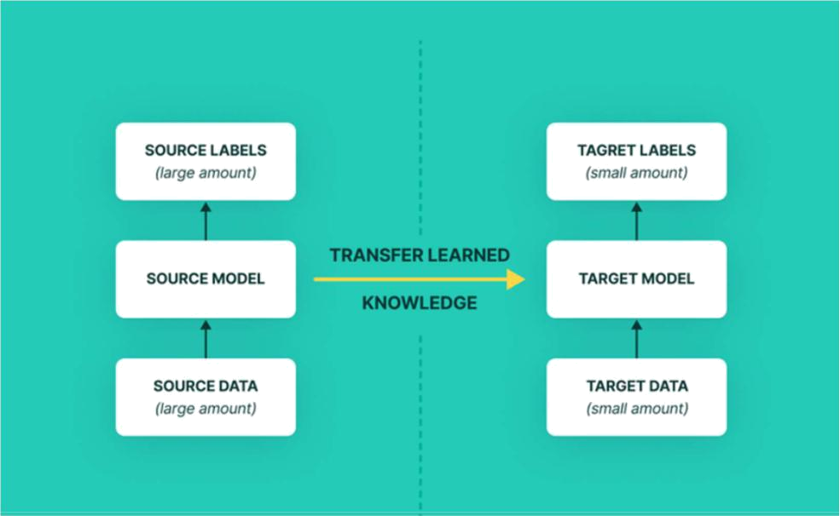

Figure 1: Block diagram of transfer learning used in the project

Here, we can see that on the left side there are source labels, source model and source data; they are made by google. The middle knowledge is what we are putting like our program and it is fitted in target labels, target model and target data and eventually we comprehend the accuracy of each model.

Transfer learning is a method for obtaining information from one environment and improving learning tasks in other situations by utilizing labelled samples from comparable distributions. Previously, transfer learning approaches were used to solve a variety of significant problems, such as learning how to learn, learning something new, and multitasking.

Process of transfer learning:

- When the model is trained it will have input layers, deep layers, hidden layers in between and finally SoftMax layer. (classifies into certain classes or categories). We are getting the feature vector using the frozen layers.

- We will freeze the between layers except for the SoftMax layer and use this layers or model to classify other things.

- We need to perform the training with the model weights.

- So, when we pass our input it passes through the training phase, which means model weights are used, and then we will get a feature vector which is a feature engineering

- Then we use softmax to classify into our wanted number of classes instead of the pre-trained model's number of classifying classes.

- Omitting the last layers is used in some approaches but in some approaches, it also freezes only 2/3 layers and the rest of the layers go through the usual NN training
- Training a huge dataset such as ImageNet and the weights obtained from the trained model can be used for any other related application with our custom neural network.

- These newly built models can directly be used for predictions on relatively new tasks or can be used in training processes for related applications.

MATERIALS

In this project we have used a pretrained model from TensorFlow hub. This tensor flow hub uses the tensor flow slim implementation of MobileNetV2 with a depth multiplier of 1.0 and pixel of 224x224. This pretrained model has 1.4 million images and has a total of 1001 classes. We apply width multipliers to all the layers except the last convolution layer which is SoftMax. This improves performance for smaller models.

The images of our custom-made dataset was originally taken from Kaggle and the Alzheimer’s Disease Neuroimaging Initiative (ADNI) public database (http://www.loni.ucla.edu/ADNI). The ADNI was initiated in 2003 by the National Institute of Biomedical Imaging and Bioengineering (NIBIB), the Food and Drug Administration (FDA), pharmaceutical companies, and non-profit organizations for the development of diverse biomarkers for the early detection of AD.

ARCHITECTURE
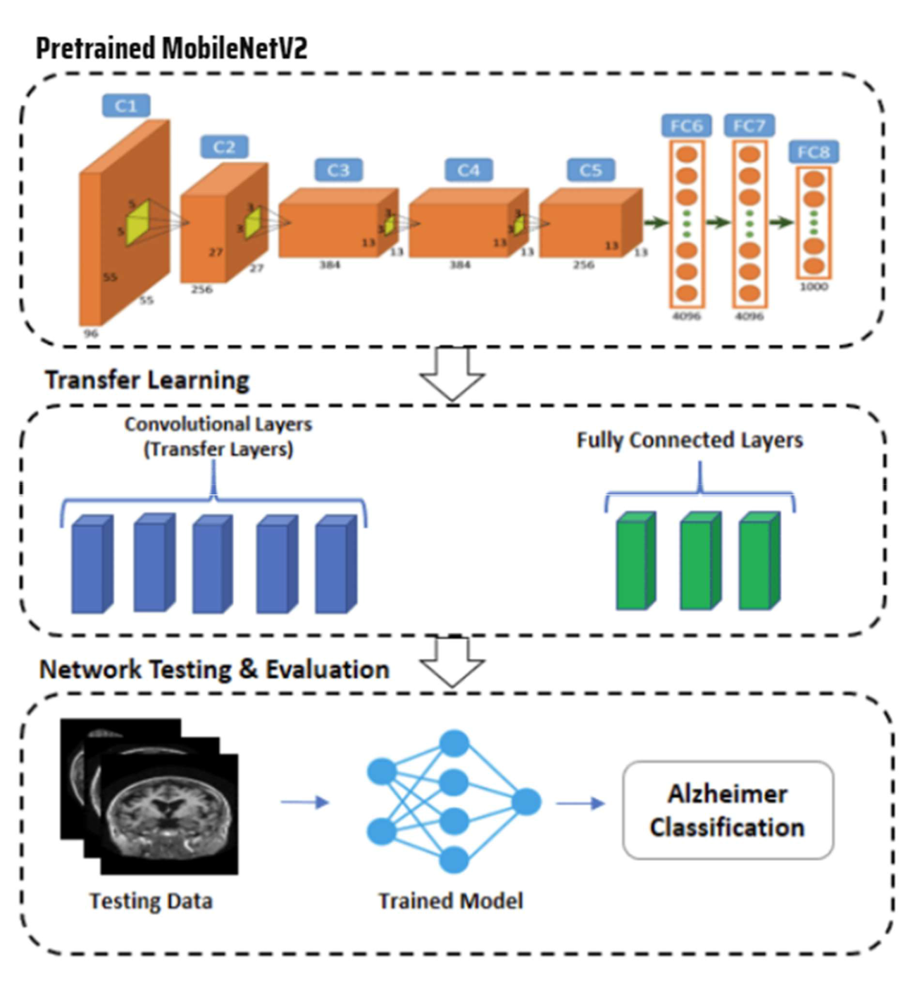

Figure 2: Architecture of the Model

WORK FLOW

- Data Processing:

  - Data download: We use a dataset containing several thousand images, download from Kaggle and ADNI; we labeled and customized our dataset as per our preference and, then create a tf.data.dataset for training and validation using the Keras utility. As the original dataset does not contain a test set, we will create one. so determine how many batches of data are available in the validation, then move 20% of them to a test set.
  - Configure the dataset for performance: Use buffered prefetching to load images from disk without having io becoming blocking.
  - Rescale pixel values: we will download keras mobilenetv2 for use as our base model. This model expects pixel values in -1,1 but at this point the pixel values are 0,225.

- Create the base model from pre trained convnets:

a.

  - We have to create the base model from the Mobilent2 model developed at google. This is pretrained on the ImageNet dataset. ImageNet is a research training dataset with a wide variety of categories. This base of knowledge will help us classify from our specific dataset.

  - First, instantiate a MobileNet v2 model preloaded with weights trained on ImageNet.
  - By specifying the include_top=False argument, we load a network that doesn’t include the classification layers at the top.

  - The feature extractor converts each 160*160*3 image into a 5*5*1280 blocks of feature.

- Feature Extraction:

  - Freeze the convolution base: we have to freeze the convolutional base before we compile and train the model. Freezing prevents the weights in a given layer from being updated during training. MobileNetv2 has many layers, so setting the entire model’s trainable flag to False and it will freeze all of them.

  - Batch Normalization layers: This layer is a special case and precautions should be taken in the context of fine tuning. When we set trainable layer to false, the batch normalization layer will run in inference mode and will not update its mean and variance statistics.
  - Add a classification head: To generate predictions from block of features, average over the spatial 5*5 spatial locations, using a global average poling layer to convert the features to single 1280 element vector per image. Applying keras dense layer to convert these features into a signle prediction per image.
- Compile the Model:

  - Compile the model before training it. the model provides a linear output

  - The 2.5 million parameters in MobileNet are frozen, but there are 1.2 thousand trainable parameters in the Dense layer.
- Train the Model:

  - Compile the model before training it. the model provides a linear output

  - The 2.5 million parameters in MobileNet are frozen, but there are 1.2 thousand trainable parameters in the Dense layer.

IMPLEMENTATION

If we unwrap the code and try to understand step by step how we proceeded with the project, we can explain as like;

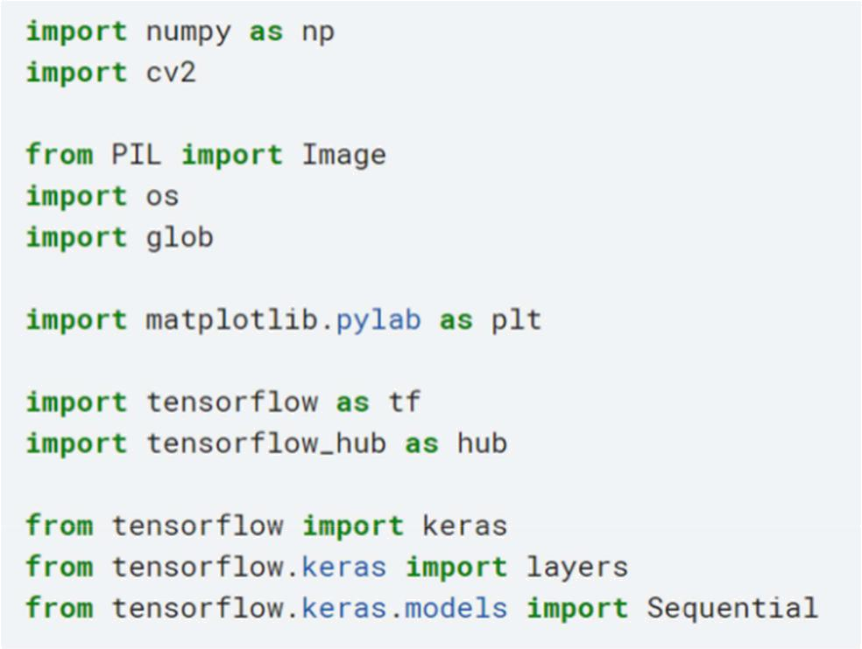

Figure 3: Importing libraries
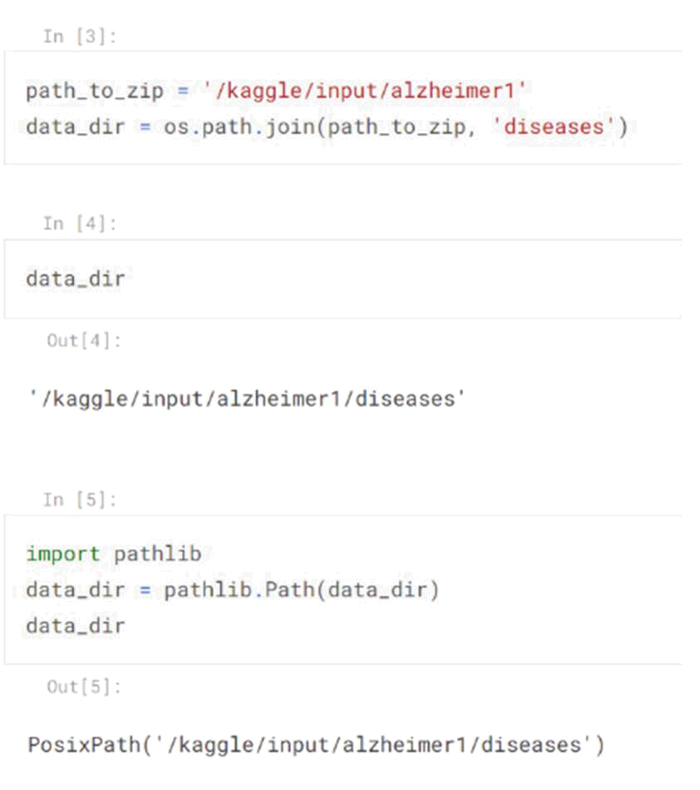

Figure 4

We are giving the path location, and saving the file as a data directory. Then, pathlib is using to convert a path and filename into a POSIX path that can be used as a parameter to a shell command
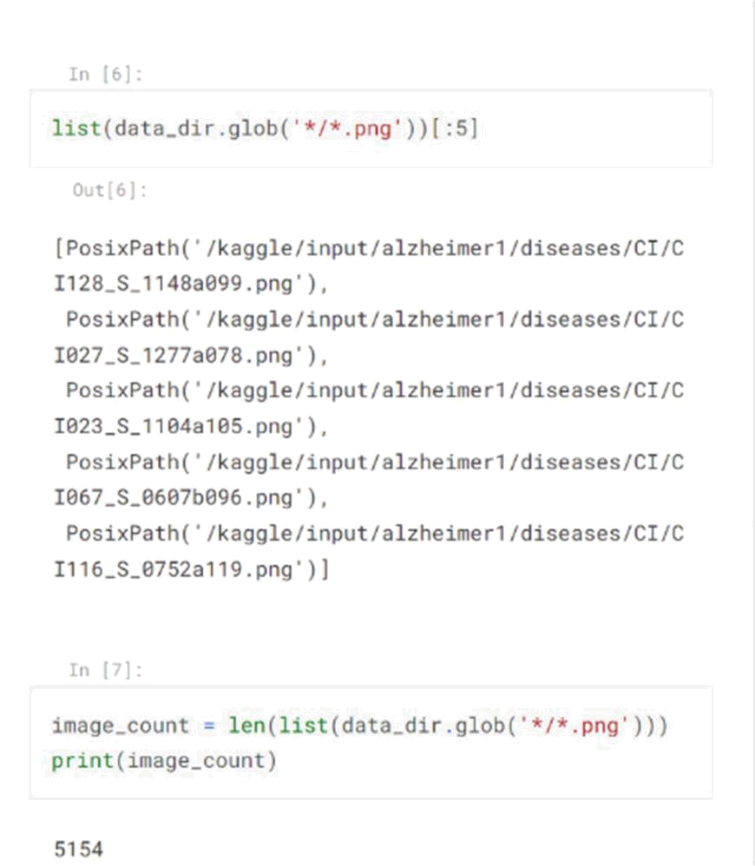

Figure 5

after doing it now we can do star.jpg or png, it will go recursively into all the directories and get use the path of individual images. And if we look at next, the image path we have 5154 images .
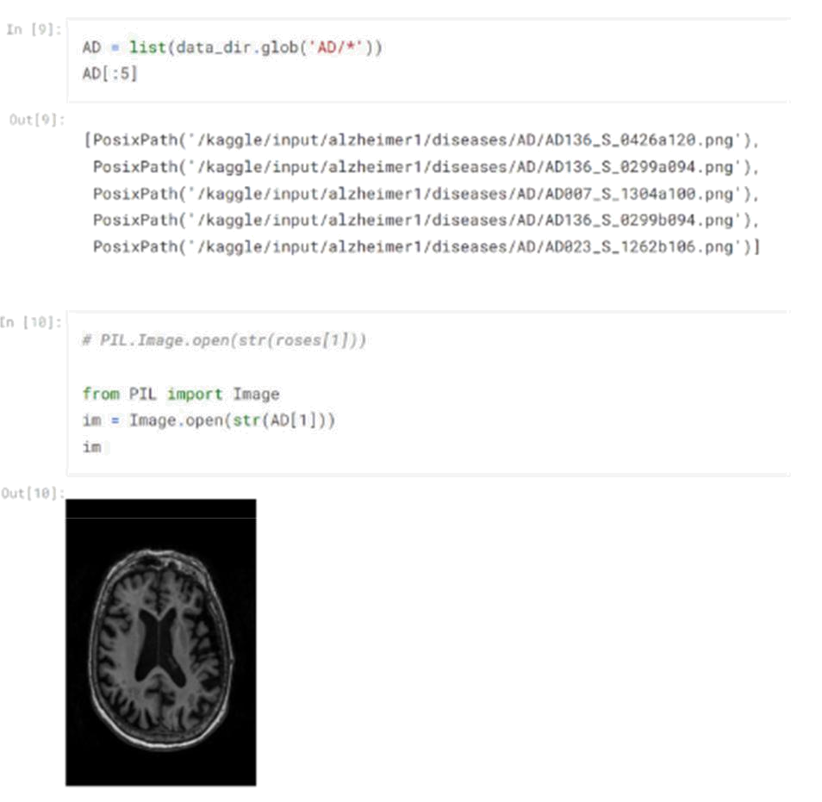

Figure 6

we are going to get all the photos that are in AD folder and we can see the AD pictures, And we import pillow library , and we use image as pillow library and we are using this code to use and open 1st row image,. Similar thing we did with CI folder and get all the images from CI , and open the image of the first row
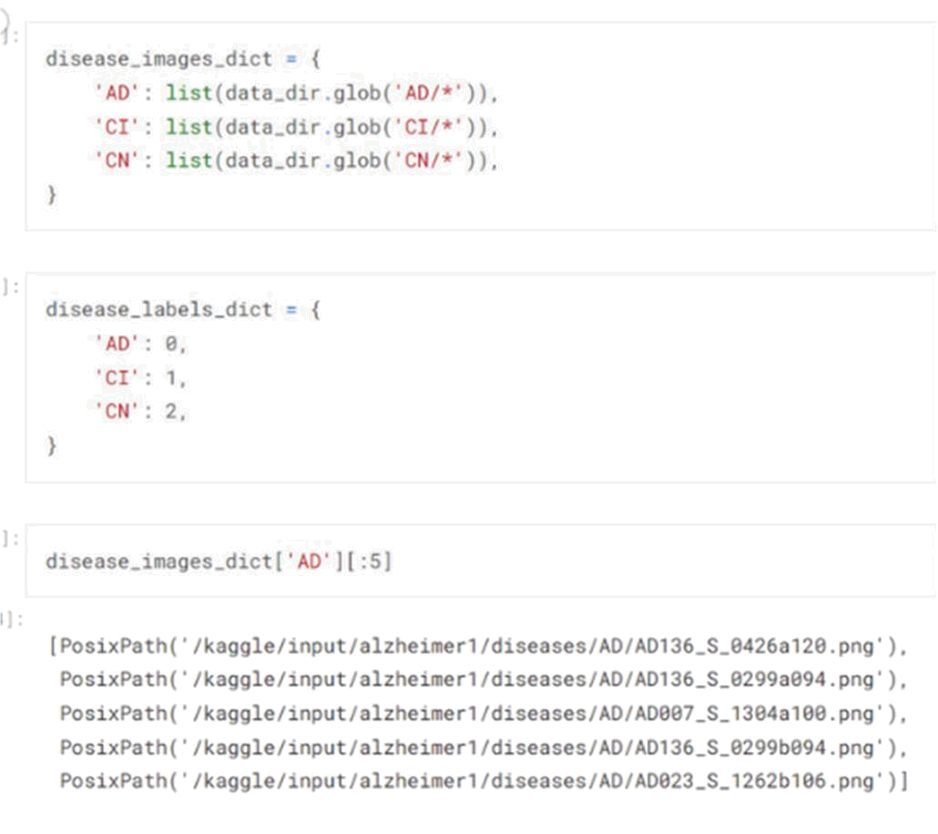

Figure 7

Now we make a python dictionary, where the key of the dictionary is the folder name and the value is the list of images. We are creating a label directory as well. Because ML module doesn’t understands stacks , so we needed to say AD = 0 , CI = 1 and CN = 2
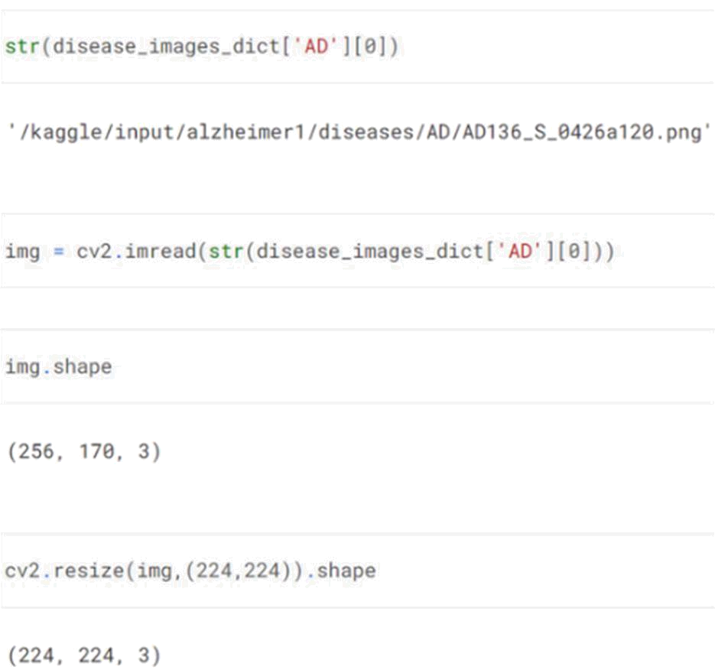

Figure 8

we are looking for a particular file path and then, we can read this into OpenCV, we are using the CV2 module which is imported at the top, and here we use imread which is image read. After we need to check all the image's shape because before training they need to be on the same size and we make images at same shape

Here we take two for loops and create x and y, for the disease image dictionary for each rows and we are going through each image which is in second for loop and also it will read each images one by one and it will resize them one by one and also we append the resize image to x, and we append the label to y
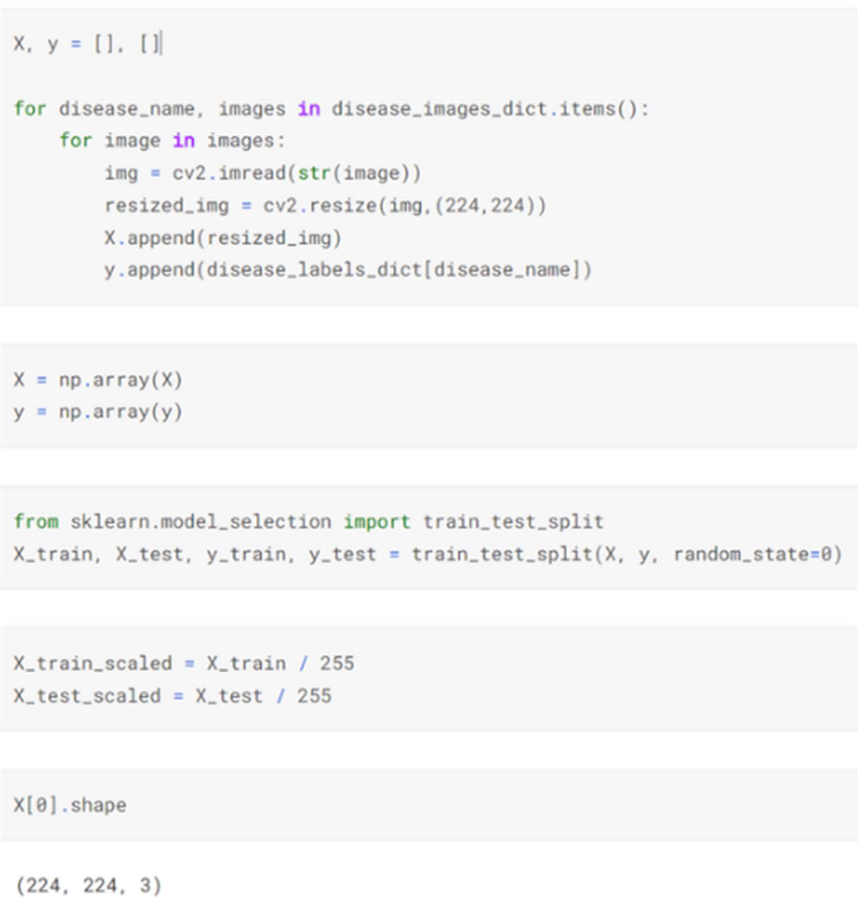

Figure 9

Before doing image classification , we have to divide it by 255, so that it can scale (value will be between 0 to 1 ), and doing this for the whole dataset numpy is so convenient . we first need to convert them into numpy array and then will divide it into 255, and in middle we need to perform train test split.
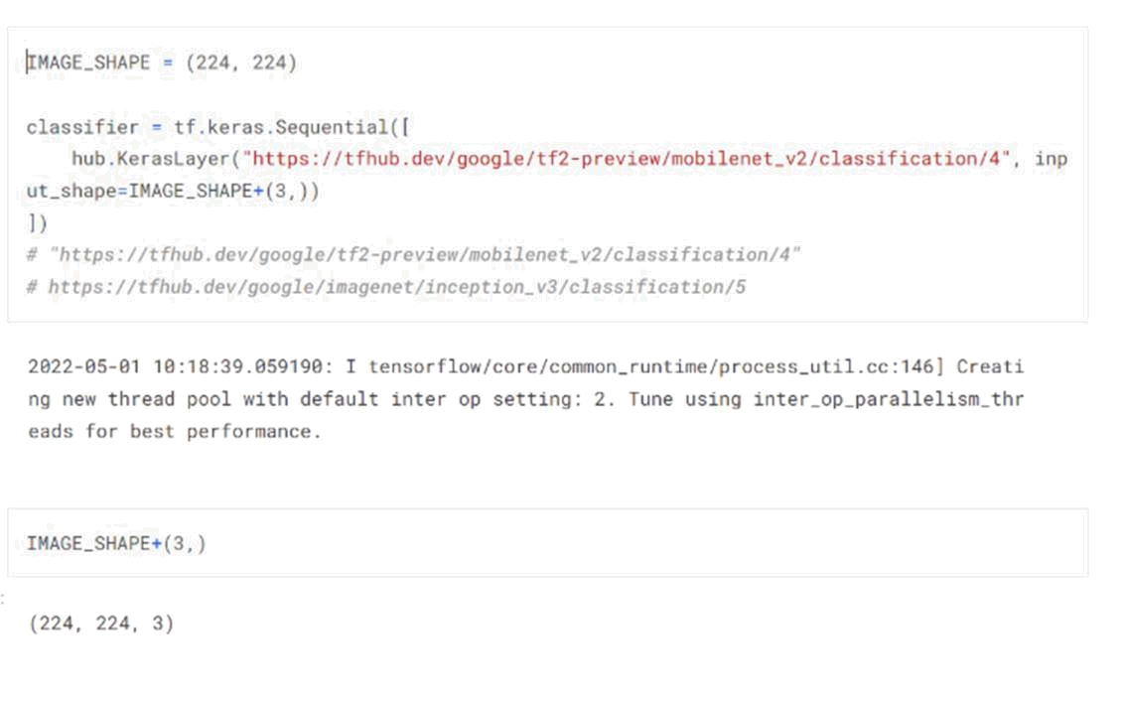

Figure 10

Now we can use a classifier to predict the model , and the classifier is the pre-trained model that we imported from the tensorflow hub.
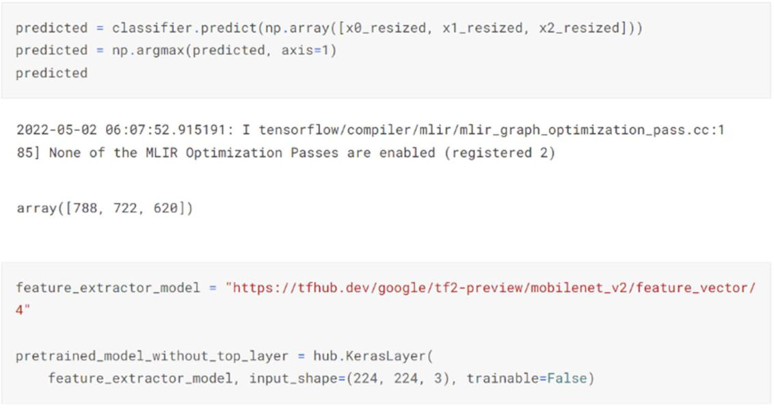

Figure 11
Here we give x0,x1,x2 and store it in the predicted and we use argmax with numpy which will give us maximum arguments. the feature extraction model uses the same pre-trained model, everything is like same except that top layer. We are using TensorFlow hub, creating Keras layer and passing this here, and input shape is a standard shape, at last, we gave trainable = false which means freeze all the layer except the first and last (sigmoid) one. Now when we perform a train all of the layers will have their fixed weights.
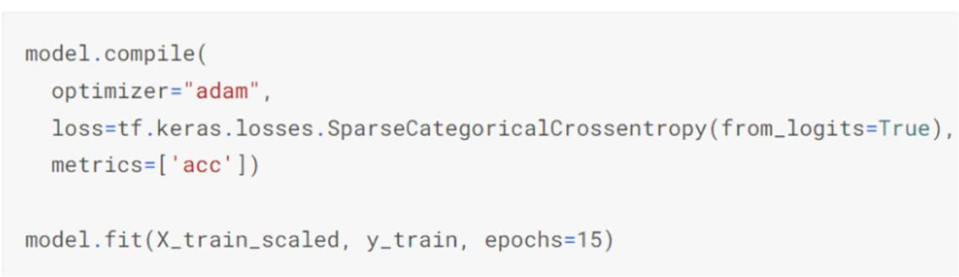

Figure 12

Then we create our model like that and initialize where we are gonna put that creating model using adam optimizer and also creating the last layer which is classification. and as we use a categorical dataset, so to evaluate loss we are using sparse categorical cross-entropy.

RESULTS
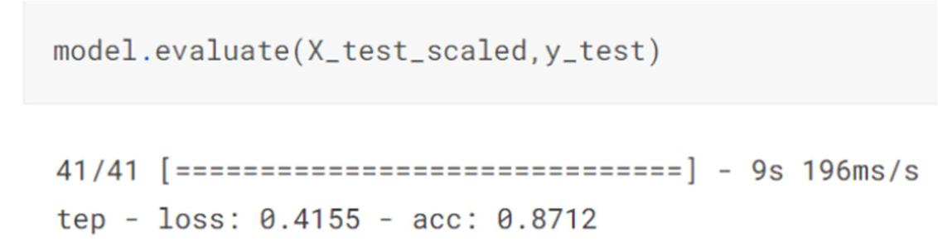

Figure 13

Last we evaluate the result where we are getting accuracy more than 87%.
FUTURE SCOPE

Data augmentation: As for future development, we can add data augmentation where we can increase the number of images by rotating, increasing or decreasing pixels, etc. by which we can have a bigger dataset and it will eventually give more accuracy

Introduction of batch size: We can also introduce the concept of the batch size where we will send each batch inside the dataset and it will give us the average and repeat likewise. This will be more efficient and give more accuracy as well.

CONCLUSION

For a disease such as Alzheimer's, which progressively degrades the size of the brain, early detection is crucial. If detection can be helped by using deep learning, then the task is made much easier, and has the potential to save, or improve thousands of lives.

REFERENCES

- MobileNetV2: Inverted Residuals and Linear Bottlenecks

- https://tfhub.dev/google/tf2-preview/mobilenet_v2/classification/4

- https://www.tensorflow.org/tutorials/images/transfer_learning

- Transfer Learning | Deep Learning Tutorial 27 (Tensorflow, Keras & Python) https://www.youtube.com/watch?v=LsdxvjLWkIY
- https://www.nia.nih.gov/health/what-alzheimers-disease

